Mount Waverley Water Main Renewal Project

Safety barriers installation -night works

We will be conducting barrier movement around our work areas as the project progresses Eastwards.

To safely do this we will have to conduct a full road closure on High Street Road between Fleet Street and Lee Avenue. These works will carried out at night when traffic movement is at their lowest.

**When:** Sunday 11 February to Sunday 19 February 2024

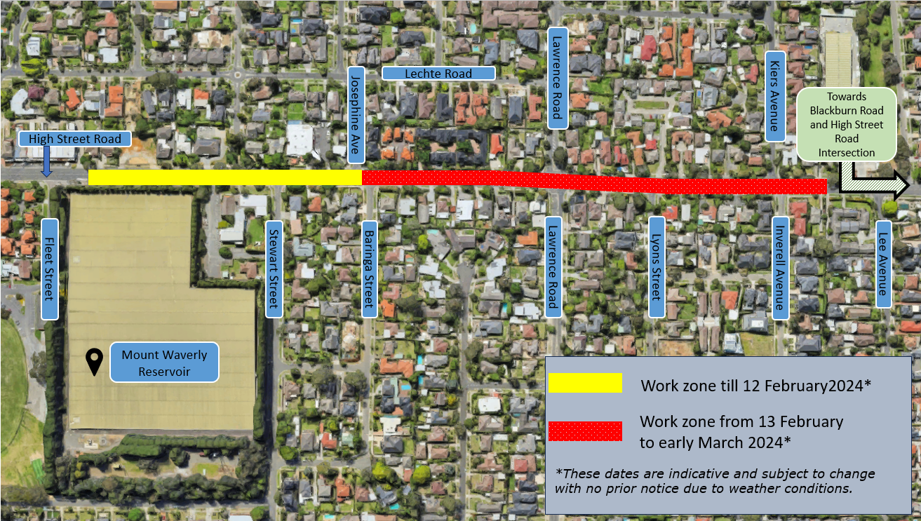**Time:** 10pm – 6am

Figure 1: Current and upcoming work zones

# What can you expect.

1. Footpaths will remain open with detours. Driveway access will be maintained for High Street Road residents. Traffic controllers will be present to assist
2. Bright lights will be used during night works. Where possible, lights will be directed away from neighbouring property windows.
3. Noise from construction equipment, construction activities and large vehicles.
4. Changes to the way you travel. Do allocate extra travel time during the period.
5. Access for emergency service vehicles will be maintained at all times during these works.

# Traffic changes on Lawrence Road intersection

Pipelaying works on Lawrence Road intersection will commence **Tuesday 13 February** and are expected to take up to three weeks to complete.

1. During this time motorist can only turn left at the intersection
2. Pedestrians will be detoured to the next intersection to safely cross the road
3. Once the intersection crossing is complete, barriers will be removed, and works will continue east towards Blackburn Road.

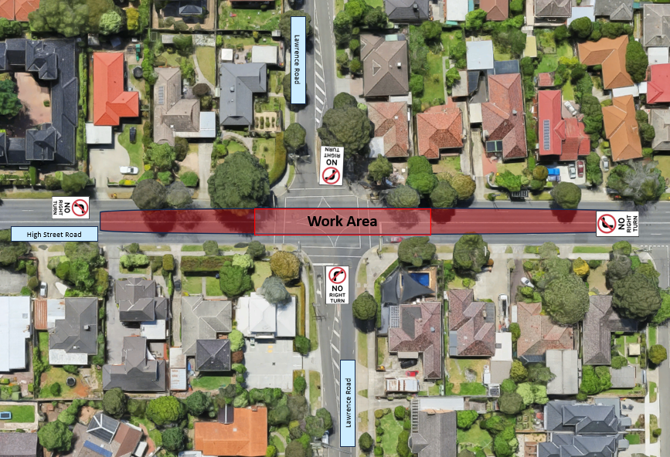

# Route 734 bus stops

To ensure the safety of commuters, bus stops within the work site area will close until it is safe to re-open. Please use neighbouring bus stops during this time.

Keep in mind there are other ongoing works being conducted in the area by Monash Council and Yarra Valley Water.

t.

